M.Sc. Business Analytics & Technologies
Module: DAT7304 Business Analytics
Assessment Report (Part A): Time Series Analysis and Forecasting
Student Name: Victor Ene
Student ID:
Submission Date: 12 May 2025

1. Introduction

1.1 Background of the Study
Fuel price fluctuations have emerged as a prominent characteristic of both global and national economic environments. These variations can significantly influence individual and business expenses while also acting as critical metric that shape public fiscal strategies and organisational decision-making frameworks. Within the United Kingdom, fuel pricing holds heightened relevance due to the impact it has on transportation logistics, its direct correlation with inflation rates and its reflection of energy market trends.
Fuel prices are a critical economic indicator influencing consumer behaviour and logistics costs. This analysis uses weekly UK fuel price data from January 2021 to February 2025 to forecast trends and identify drivers of volatility. The dataset includes average fuel prices, road fuel sales and an external dataset of Brent crude oil prices.
Time series analysis has emerged as a powerful technique in business analytics, enabling analysts to make data-driven forecasts based on historical trends and patterns. With the availability of high frequency fuel price data in the UK and access to exogenous variables such as global crude oil prices, it is now possible to construct robust models that can provide short and long term forecasts with high accuracy. This report applies various techniques relating to time series to analyse, uncover patterns, model and forecast weekly average fuel prices in the UK, aiding stakeholders in strategic decision-making.

1.2 Business Problem Statement
Fluctuating fuel prices present significant challenges for UK fuel retailers, policymakers and consumers. The business in focus is a UK fuel retail chain operating a network of stations with key stakeholders including retail managers, Logistics providers, policy makers and consumers, Despite historical fuel price data, there is no robust forecasting system currently in place to help stakeholders anticipate future price movements and make informed policy or pricing decisions. Can we accurately forecast UK average fuel prices using historical time-series data and relevant external variables such as crude oil prices?, This question is of strategic importance for stakeholders as an effective forecasting model can enable better budgetary planning, inventory management and policy formulation. Businesses can develop contingency plans for fuel shortages and consumers gain access to transparent pricing trends to inform budgeting decisions.

1.3 Significance of the Problem
Fuel prices pose systemic risks to economic stability, supply chain efficiency, and household financial planning, fuel costs directly influence inflation, transport logistics and energy policy, the inability to anticipate price movements can create vulnerabilities across sectors. The significance of this problem is underscored by its impact on:
- Government Budget Planning: Volatile fuel prices complicate fiscal strategies, particularly in forecasting subsidies or price stabilisation schemes.
- Private Sector Logistics: Transport firms and fuel retailers face operational inefficiencies, such as mismatched inventory levels or unplanned fuel surcharges.
- Consumer Welfare: Unpredictable fuel prices make it harder for households, particularly those on low incomes, to balance their budgets.
- Inflation Control: Fuel prices are a key driver of inflation, influencing transport, manufacturing, and commodity costs. Unchecked volatility risks broader economic instability.
This report employs advanced time-series methodologies to address stakeholder needs by predicting average fuel prices 24 weeks ahead, enabling fuel retailers to optimise pricing strategies. This reduces financial losses sudden price drops, while logistics firms can align transport schedules with anticipated fuel costs to minimise operational disruptions and improve cost analysis.
Identifying seasonal patterns and trends via decomposition techniques to reveals trends, retailers can leverage these insights to time promotional campaigns or adjust stockpiling strategies and enhance competitiveness. And the analysis quantifies the causal impact of crude oil prices on UK fuel markets using Granger causality tests and multivariate models. Together, these outputs equip stakeholders with tools to mitigate volatility-driven risks and foster economic resilience.

1.4 Business Questions
The following business questions guide the analysis and modelling in this report:
- Are there trends and seasonal patterns in UK average fuel prices?
- Do crude oil prices influence average fuel prices in the UK?
- Does average road fuel sales volume influence the accuracy of multivariate time-series forecasts?
- Which forecasting model provides the best accuracy for UK fuel prices?
- What are the forecasted average fuel prices for 12 weeks into the future using historical patterns?

2. Literature Review
Accurate fuel price forecasting is critical for policymakers, businesses and consumers, particularly in oil-importing economies like the UK, where fuel prices influence inflation, transportation costs and economic stability (Hamilton, 2010). Crude oil is at the heart of these price dynamics and plays a central role in driving price fluctuations with Brent crude serving as a critical global benchmark, especially for European markets. As a major driver of refined petroleum product pricing, Brent crude prices directly shape cost structure across the supply chain and as such, understanding and predicting its impact is fundamental to any fuel price forecasting strategy (Baumeister and Kilian, 2015). Recent geopolitical shocks (Russia-Ukraine crisis, COVID-19) and energy transitions necessitate the need for robust models to address structural breaks and uncertainty (Moyo, Anyikwa and Phiri, 2023).
Time-series analysis has long been integral to business forecasting and is widely used to model fuel price dynamics. The foundational work of Box and Jenkins (1976) established Autoregressive Integrated Moving Average (ARIMA) models, which laid foundation for researchers to make advancements in seasonal (SARIMA), exogenous-inclusive (ARIMAX) and multivariate (VAR) extensions. Methodologies have evolved from traditional models such as ARIMA and VAR to machine learning and hybrid approaches, which better capture non-linearities and volatility (Hyndman and Athanasopoulos, 2021). In fuel pricing research, both univariate and multivariate methods have been explored. For instance, Lin and Li (2015) identified predictive links between global oil prices and domestic fuel costs using Granger causality tests. Similarly, Chao et al. (2020) demonstrated that multivariate frameworks integrating crude oil prices and macroeconomic variables such as exchange rates and crude oil price yield superior accuracy to conventional ARIMA models.
Machine learning techniques, such as Support Vector Regression (SVR), Random Forests, ANNs and LSTMs, have also gained traction for capturing non-linear relationships in fuel price data (Gupta and Nigam, 2020). Guo et al. (2019) argue that these non-linear machine learning models often outperform statistical models when dealing with complex, non-linear relationships in the data, although their interpretability remains a challenge. The research by Jha et al. (2024) investigated crude oil price forecasting using multivariate techniques, with a focus on overcoming the limitations of traditional econometric models. The study found that Support Vector Regression (SVR) with a radial basis function (RBF) kernel outperformed other methods, demonstrating superior stability and accuracy in capturing the non-linear and time-varying dynamics of crude oil prices.
This report builds on existing literature by comparing a comprehensive suite of forecasting models, from classical statistical to modern machine learning approaches, while also considering the influence of exogenous variables like Brent crude oil prices and average road fuel sales.

3. Methodology

3.1 CRISP DM
The Cross-Industry Standard Process for Data Mining (CRISP-DM) is a globally accepted framework that offers a systematic approach to manage the data mining process and ensure effective execution (Putler and Krider,2012a). Comprising of six interconnected phases, this methodology is essential for structuring data analysis tasks, such as time series prediction, by addressing the requirements of each phase. The following discussion outlines these CRISP-DM phases and their relevance to predicting average fuel prices in the United Kingdom through historical trends and external influencing factors.
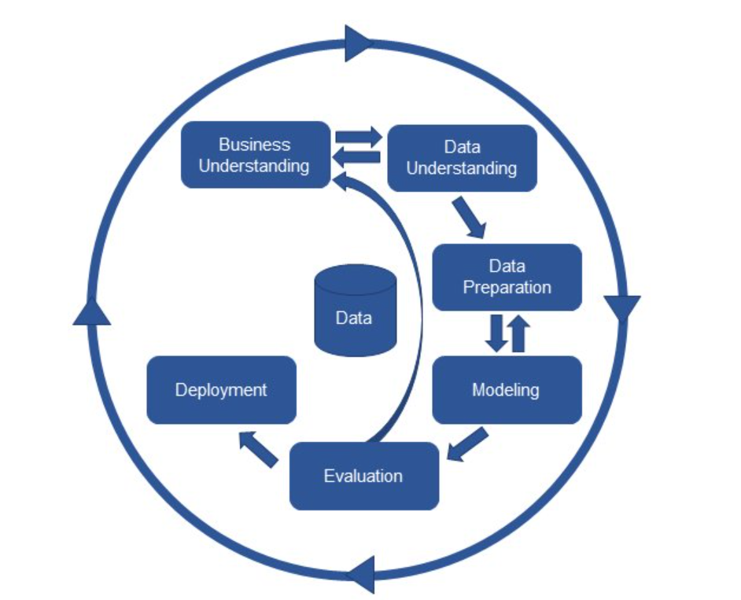
Figure 1 CRISP - DM Model (Taylor, 2017)
- Business Understanding
The Business Understanding phase establishes the project goals aligned with stakeholder priorities and organisational needs, evaluation of the business is necessary to identify existing resources and gaps, ensuring it aligns with project requirements. This phase is critical for framing the problem and defining measurable outcomes (Schröer, Kruse and Gómez, 2021). This report addresses volatile UK fuel prices by developing a 24-week forecasting model using historical data and external variables and a structured plan with success criteria being predictive accuracy.
- Data Understanding
The Data Understanding phase involves collecting, describing, and exploring the available data to identify data quality issues and initial insights (Schröer, Kruse and Gómez, 2021). For this analysis data has been sourced from weekly fuel prices (Jan 2021 – Feb 2025) and aggregated Brent crude oil prices supported by statistical descriptions and attribute correlations. Exploratory analysis using line plots, STL decomposition, and stationarity tests identified seasonal patterns and non-stationary trends in the data.
- Data Preparation
The Data preparation phase involves is cleaning, transforming, defining inclusion and exclusion criteria and structuring data for modelling. The methodologies applied across these steps are model-dependent, as the choice of techniques must align with the specific requirements and assumptions of the selected algorithm (Schröer, Kruse and Gómez, 2021).
- Modelling
The modelling phase entails selecting and applying data mining techniques tailored to the business problem and data characteristics, guided by frameworks like CRISP-DM, followed by evaluation against predefined metrics to identify the most effective model (Han, Pei and Tong, 2023).
- Evaluation
The Evaluation phase assesses whether model outcomes align with predefined business goals, requiring interpretation of results and formulation of actionable recommendations. The entire analytical process is reviewed to identify improvements, ensuring alignment with operational workflows and stakeholder expectations (Putler and Krider,2012b). The best model is chosen based on its ability to predict future values accurately.
- Deployment
The final work could be a report or a software, the Deployment phase involves using the chosen model for actual decision-making. This could involve integrating the model into the business process for real-time predictions or using it for policy recommendations (Schröer, Kruse and Gómez, 2021). The best-performing model, identified through evaluation was used to generate 24 week forecasts for future fuel prices.

3.2 Dataset
The primary dataset used in this study comprises weekly observations of average fuel prices, estimated quantity demand per transaction and average road fuel sales, starting from January 2021 to February 2025. An additional external dataset, containing daily Brent crude oil prices was sourced from the U.S. Energy Information Administration (EIA). This data was aggregated to a weekly averages to align with the main dataset. Both datasets are non-seasonally adjusted, requiring preprocessing to handle missing values and outliers, the datasets were cleaned, merged and analysed using R programming.

3.3 Model Descriptions
The following models were employed to analyse and forecast UK fuel prices from January 2021 to February 2025, leveraging both traditional time-series techniques and machine learning approaches. Each model is described below.
- SARIMA
The Seasonal Autoregressive Integrated Moving Average (SARIMA) model is an extension of the ARIMA framework, designed to capture autoregressive, differencing, moving average components and also seasonal patterns in data with periodic trends making it particularly suitable for time series data with recurring patterns (Hyndman and Athanasopoulos, 2021). such as the 52-week cyclical patterns identified in weekly UK fuel prices. The model combines non-seasonal parameters (p, d, q) and seasonal parameters (P, D, Q, s), where p and P represent autoregressive terms, d and D represent differencing orders, q and Q represent moving average elements, and s is the seasonal interval (Hyndman and Athanasopoulos, 2021). Applied to fuel price forecasting, SARIMA captured historical trends and seasonal variations, generating reliable predictions, however, its efficacy depends on linear assumptions.
- STLF (Seasonal Time Series Forecasting using Loess)
The STLF model is a seasonal forecasting method that applies Seasonal and Trend decomposition using Loess (STL) to decompose the time series into its seasonal, trend, and remainder components. After decomposition, exponential smoothing is applied to the seasonal and trend components to generate forecasts. Unlike traditional ETS (Error-Trend-Seasonal) models, which directly smooth the entire time series, STLF first performs seasonal decomposition using Loess, which allows for more flexibility in handling seasonality that may change over time. This model is highly effective for weekly or daily time series that exhibit irregular seasonality patterns, as seen in many economic indicators like fuel prices (Hyndman and Athanasopoulos, 2021).
- Holt-Winters
The Holt-Winters model (triple exponential smoothing) builds on exponential smoothing by incorporating level, trend, and seasonality adjustments through three optimised smoothing parameters to reduce forecasting errors (Chatfield, 2000). Applied to UK fuel price data, it is suitable for datasets with steady periodic patterns. However, its reliance on historical trends limits adaptability to abrupt external shocks, such as oil price volatility, which may introduce non-linear dynamics.
- VAR
The Vector Autoregression (VAR) model is a multivariate time-series approach that models the interdependencies among multiple related variables. Unlike univariate models, VAR treats each variable (e.g., fuel prices, oil prices, road fuel sales) as a function of its own lagged values and the lagged values of all other variables in the system. In this study, VAR was employed to capture the dynamic relationships between fuel prices, Brent crude oil prices, and road fuel sales. VAR is well suited for exploring Granger causality and forecasting in interconnected systems, though it requires stationarity and can be sensitive to model specification (Lütkepohl, 2007).
- DLM
The Dynamic Linear Model (DLM) is a state-space methodology that employs Kalman filtering to represent time-series data through a combination of observable measurements and unobserved components, such as trends, cyclical or seasonal patterns, making them highly adaptable to changing conditions permitting parameters to evolve over time and the integration of external variables (Durbin and Koopman, 2012). In this analysis, DLM was applied to model fuel prices as a state-space system, estimating latent trends and seasonal components while adapting to structural changes in the data. Using Kalman filtering enables robust handling of missing values and outliers, However DLM can be computationally intensive and require careful specification (Harvey, 2003).
- SARIMAX
The Seasonal Autoregressive Integrated Moving Average with Exogenous Variables (SARIMAX) model is an extension of the SARIMA framework that integrates external predictors, or exogenous variables, to improve the modelling of time-series data influenced by external factors (Hyndman and Athanasopoulos, 2021). In this report, SARIMAX was used to model fuel prices while including Brent crude oil prices and road fuel sales as exogenous variables. Like SARIMA, it accounts for autoregressive, differencing, and moving average components, as well as seasonal patterns, but its ability to integrate covariates makes it more robust for multivariate analysis and computational demands also escalate with the inclusion of multiple covariates (Alharbi and Csala, 2022).
- SVR
Support Vector Regression (SVR) is a machine learning technique that applies the principles of support vector machines to regression problems. SVR seeks to find a function that predicts continuous values rather than categorical labels while maintaining a margin of tolerance around the true data points, using a kernel most notably Radial Basis Function (RBF) to capture non-linear relationships. In this study, SVR was used to model fuel prices, incorporating lagged fuel prices, oil prices and road fuel sales as features. SVR is particularly effective for datasets with non-linear dynamics but requires careful tuning of hyperparameters like kernel selection and large datasets may escalate training times (Gupta and Nigam, 2020; Smola and Schoelkopf, 2004).
- Random Forest
Random Forest is a machine learning model that constructs multiple decision trees during training and aggregates their predictions by majority voting or averaging to improve accuracy and robustness. In time-series forecasting, it adapts to temporal data by treating lagged values of the target variable and exogenous predictors as input features. In this report, Random Forest was applied to forecast fuel prices, leveraging features such as lagged fuel prices, oil prices, and road fuel sales. Its strength lies in its ability to capture complex, non-linear relationships and handle high-dimensional data while mitigating overfitting through randomness in tree construction (Breiman, 2001; James et al., 2013).

4. Implementation and Results

4.1 Data Preprocessing and Exploratory Data Analysis
Data Preprocessing ensures that the data is in the correct format for analysis and modelling, if the data is not appropriately structured our results may encounter errors or incorrect results during analysis and modelling. Exploratory Data Analysis is a critical first step in any data analysis project where you examine and visualise your dataset to understand its main characteristics, general patterns, relationships and potential issues before applying formal modelling or testing procedures. The following steps were performed using R programming.

4.1.1 Data Import
The dataset was imported using the read_excel function, with metadata rows skipped. Columns were renamed to make the column names easier to work with and more meaningful for further analysis. The data is then converted to appropriate types using mutate function from dplyr package, mutate is used to transform the data, creating new columns or modifying existing ones. The str() function provides an overview of the structure of the fuel data frame, displaying the data types of all columns, the first few rows of data and the number of observations and variables in the dataset as shown in figure 3 below, confirming that the columns have been correctly transformed and that the data is ready for analysis.
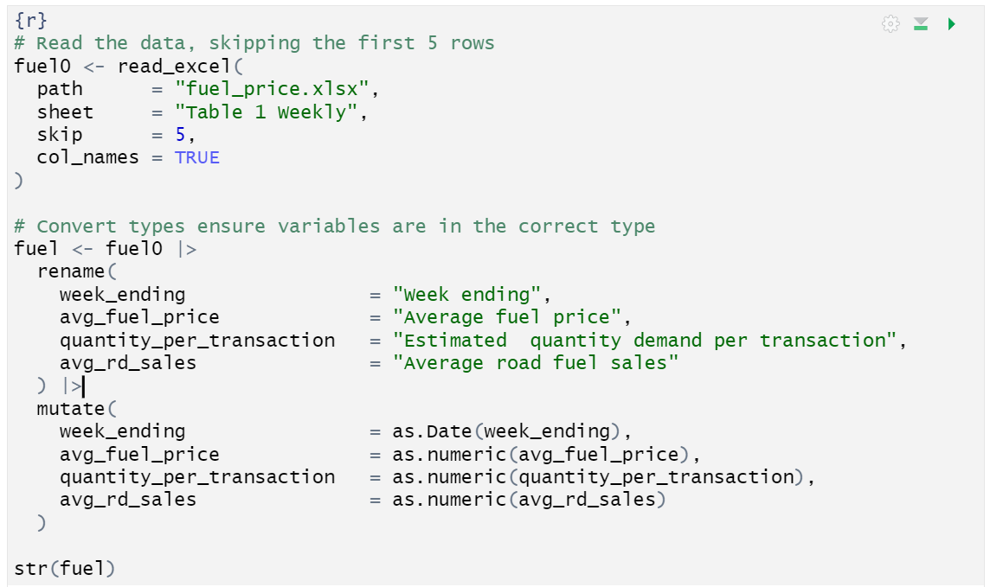
Figure 2. Importing and structuring the fuel price dataset.

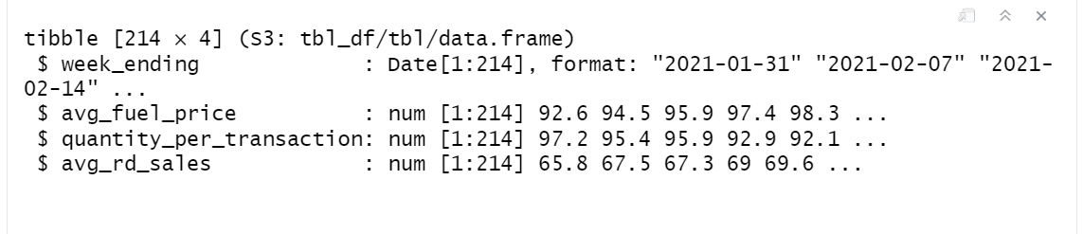
Figure 3. Fuel data structure.

4.1.2 Missing Values
Missing values in avg_fuel_price, quantity_per_transaction and avg_rd_sales were addressed using linear interpolation and forward-fill techniques as shown in figure 5. The line “fuel |> summarise_all(~ sum(is.na(.)))” checks for missing values across all columns of the fuel dataset, after importing the data it had 15 missing values across the numerical column as shown in figure 4 below.
Figure 4. Missing values
After identifying the missing values, Linear interpolation filled in missing values by interpolating linearly between known data points. It works well when the data is expected to change gradually over time, although linear interpolation is a powerful technique, we still had missing values in the avg_rd_sales column which was handled using Forward filling which fills in missing values by copying the previous non missing value forward, it is appropriate for situations where we assume that the last known value holds until we get a new value, after using forward fill our data no longer had any missing values as shown in figure 6.

Figure 5. Missing values after linear interpolation

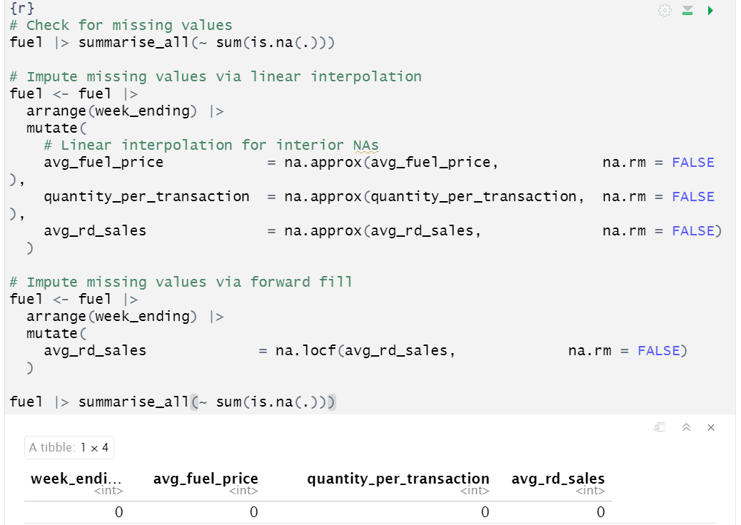
Figure 6. No missing values

4.1.3 Outlier Detection
IQR-based detection revealed significant outliers which were replaced with NA and interpolated using na.approx function. Outliers are highlighted on a boxplot as shown in figure 7 and a line plot of the fuel prices in figure 8, we found the indices of the outlier points at index 190 and 202 by checking for values in avg_fuel_price that are either below the lower bound or above the upper bound.
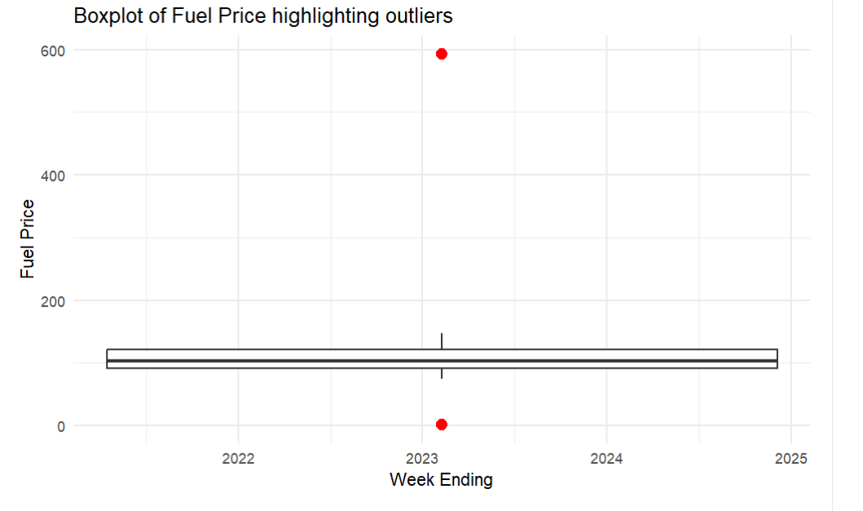
Figure 7. Boxplot showing outliers

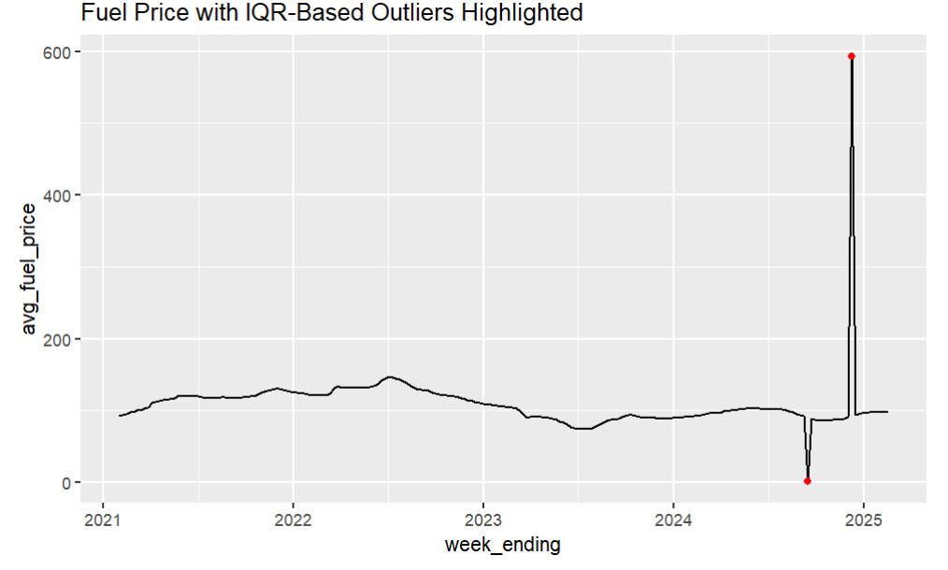
Figure 8. Line plot showing outliers

After imputation, the dataset no longer contained outliers as shown in figure 9 below, making the dataset ready for analysis.
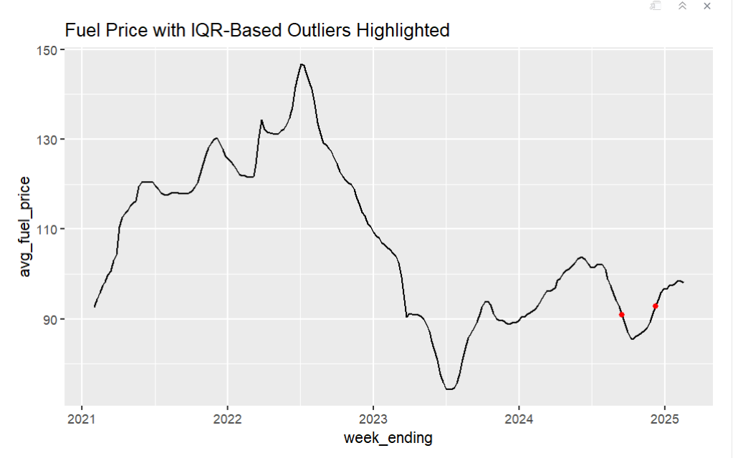
Figure 9. Line plot showing no outliers

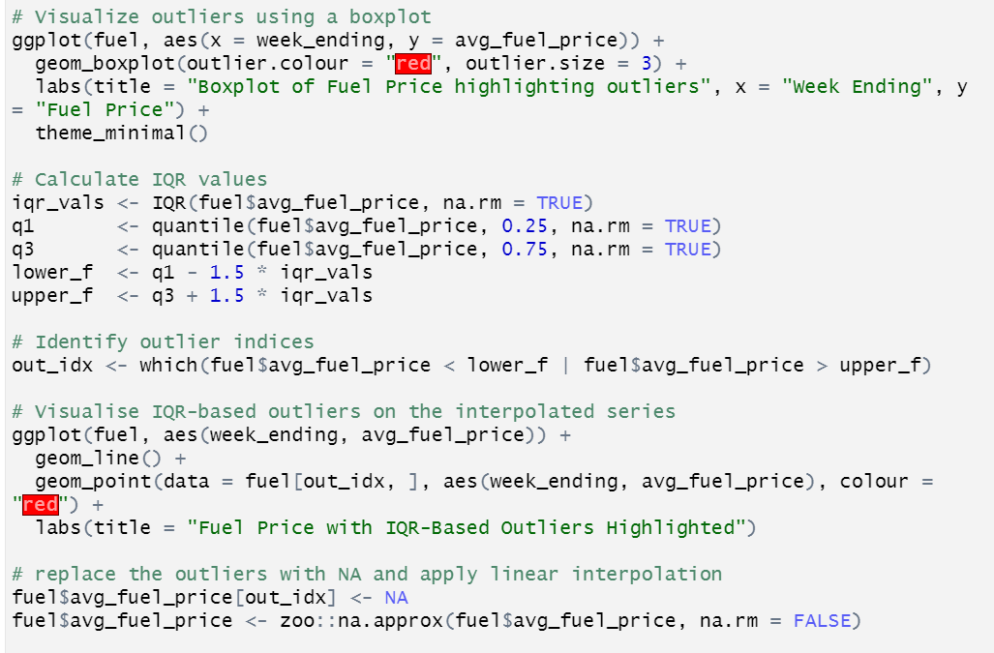
Figure 10. Outlier Detection Code

4.1.4 Duplicates
Duplicate entries were identified in the dataset. These duplicates represent multiple observations recorded for the same week which could distort the analysis. The identified duplicates are as shown in figure 11 below.
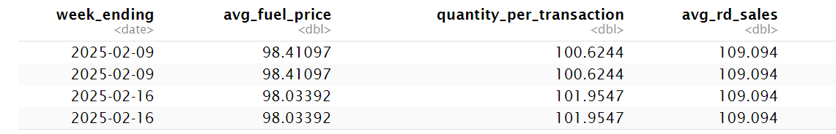
Figure 11. Duplicates
Both of these weeks had duplicate rows with identical values across all columns. To address this issue, the dataset was aggregated by week to remove the duplicates. The mean of the duplicated rows was calculated for each week, ensuring that there was only one representing entry per week based on the average of the duplicate values for each column.
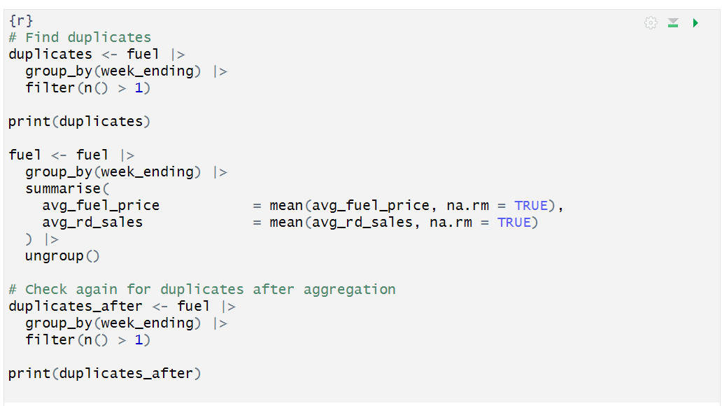
Figure 12 Duplicates code snippet

4.1.5 Decomposition
In this analysis, time series decomposition was performed using STL decomposition which help separate the time series into its three components trend, seasonality and remainder (residual) and is useful for capturing seasonal patterns and understanding the long-term trend in the data and the Hodrick-Prescott (HP) filter used to separate the long-term trend from the cyclical components in the data, focusing more on economic applications to analyse cycles giving a clearer view of both short-term fluctuations and long-term trends. Both methods can be used to quantify seasonality, but the STL decomposition method is more versatile and commonly used for analysing time series with strong seasonal patterns.
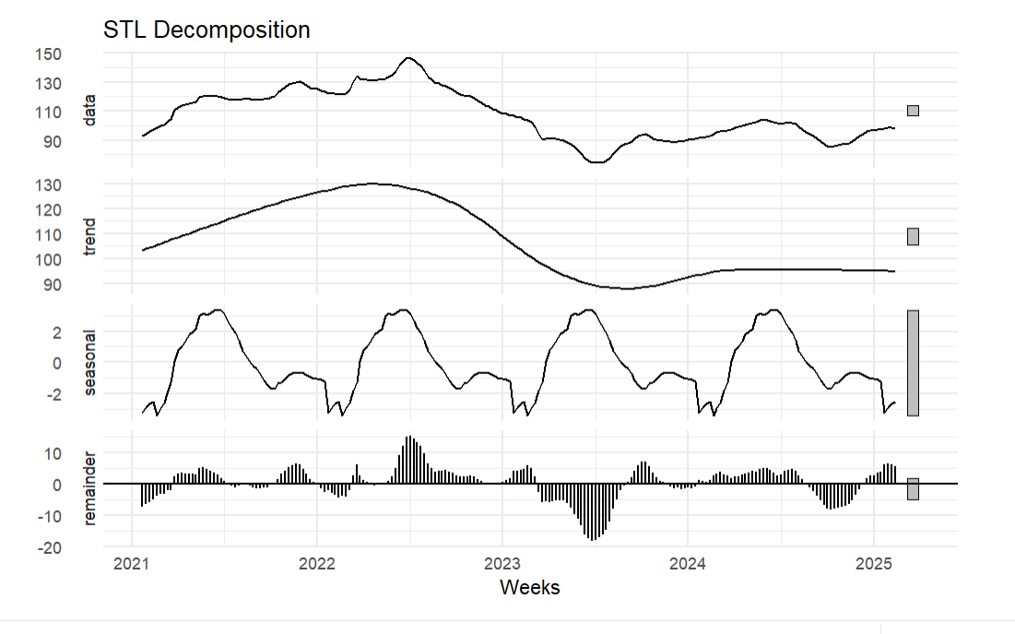
Figure 13. STL decomposition plot
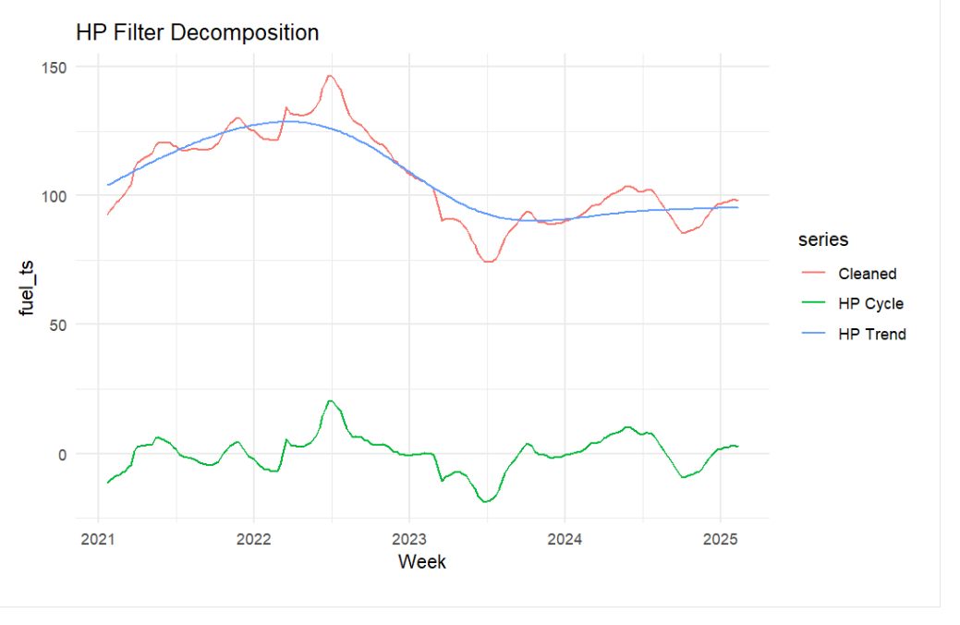
Figure 14 HP Filter decomposition

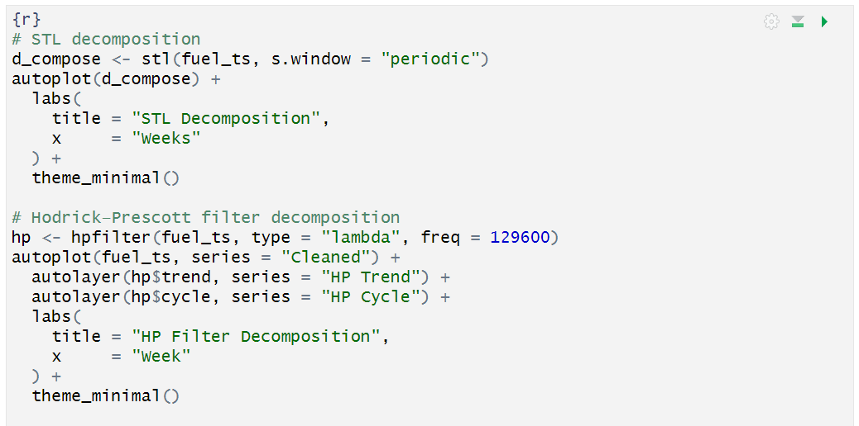
Figure 15. Decomposition code

4.1.6 Stationarity
The stationarity on the original time series fuel_ts was checked using the Augmented Dickey-Fuller (ADF) test, the ADF test is a statistical test used to check the stationarity of a time series, a time series is stationary if its statistical properties like mean and variance do not change over time, a non-stationary time series often exhibits trends, seasonality or other patterns that vary over time.
The result showed a p-value of 0.3854, indicating that the series is non-stationary. After differencing the series, the ADF test p-value becomes 0.01, allowing us to reject the null hypothesis since it is less than 0.05 and confirm that the differenced series is stationary. This means that differencing was successful in making the time series stationary, enabling the use of time series models like SARIMA.
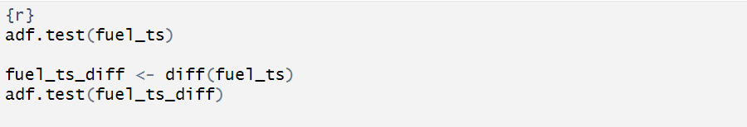
Figure 16. Stationarity testing with ADF.

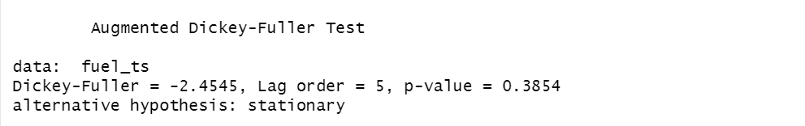
Figure 17 ADF test result

Figure 18 ADF test result after differencing

4.1.7 ACF/PACF
The ACF (Autocorrelation Function) and PACF (Partial Autocorrelation Function) plots are used to help determine the appropriate order of the Autoregressive and Moving Average components in time series models such as ARIMA or SARIMA.
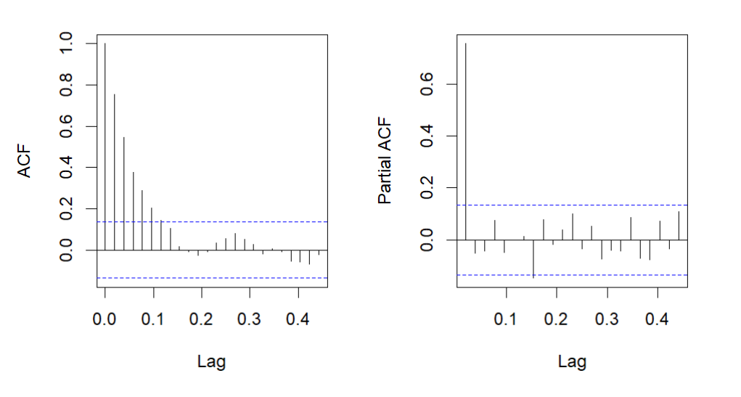
Figure 19 ACF / PACF plots

4.2 Univariate Models
Each model was trained using an 80/20 train and test split, by using 80% of the data for training, the model has enough historical data to learn patterns, trends and relationships. This allows the model to capture the underlying structure of the time series and perform well on unseen data.
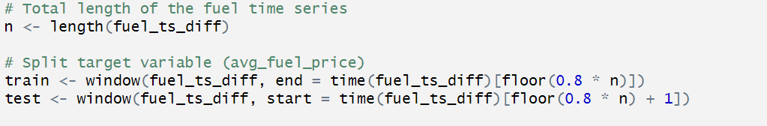

4.2.1 SARIMA
The SARIMA model was fitted using auto.arima() to automatically select parameters, capturing seasonal patterns which automatically identifies the optimal parameters for the SARIMA model based on the training data. After fitting the model to the training data, the forecast() function generates predictions for future time periods, with the forecast set to match the length of the test dataset to facilitate comparison between predicted and actual values. Finally, the code visualises the results using the plot() function to display the historical data alongside the forecasts
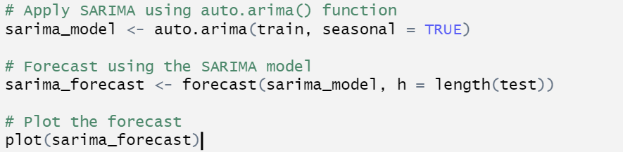
Figure 20 SARIMA fitting and forecasting

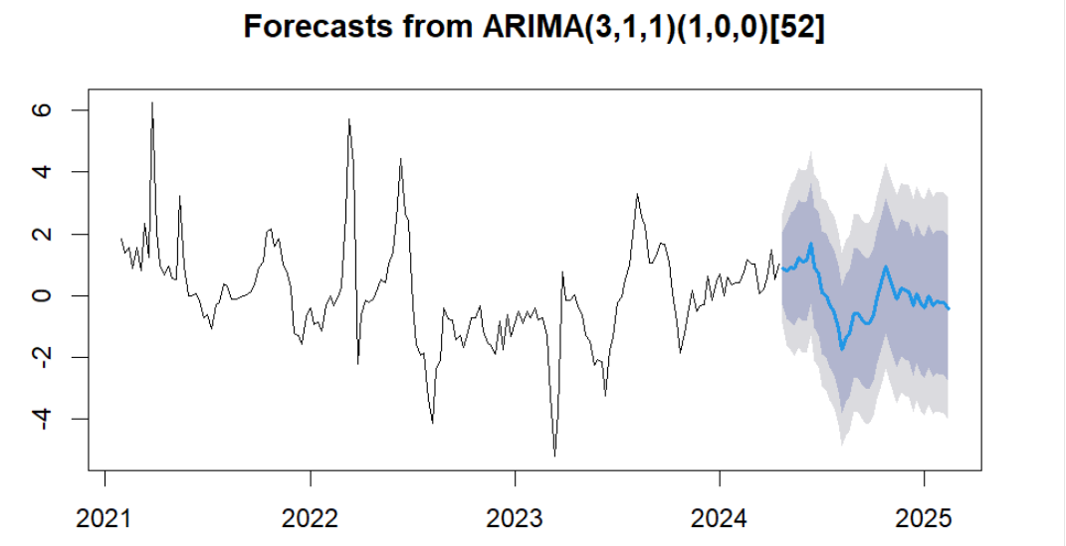
Figure 21. ARIMA forecast plot
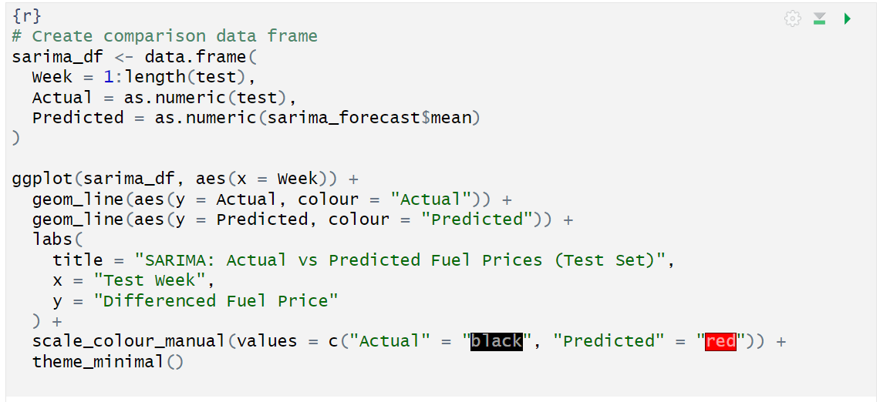
Figure 22. SARIMA actual vs predicted code

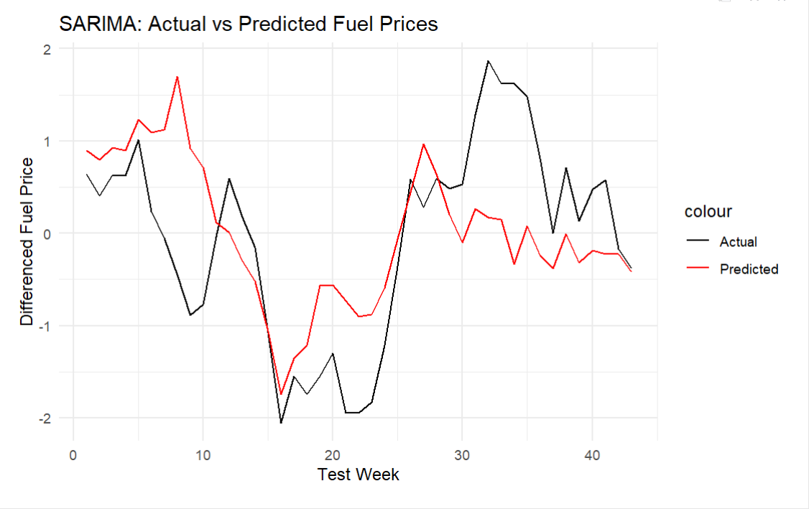
Figure 23. SARIMA actual vs predicted plot

4.2.2 Holt-Winters
Using the HoltWinters function, the model is fitted to historical training data as shown in figure 24 below, forecasts for future time periods are then generated with the prediction horizon set to the length of the test dataset. This enables a direct evaluation of forecast accuracy by comparing predicted values against actual observations.
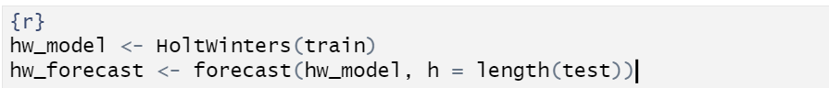
Figure 24. Fitting Holt - Winters
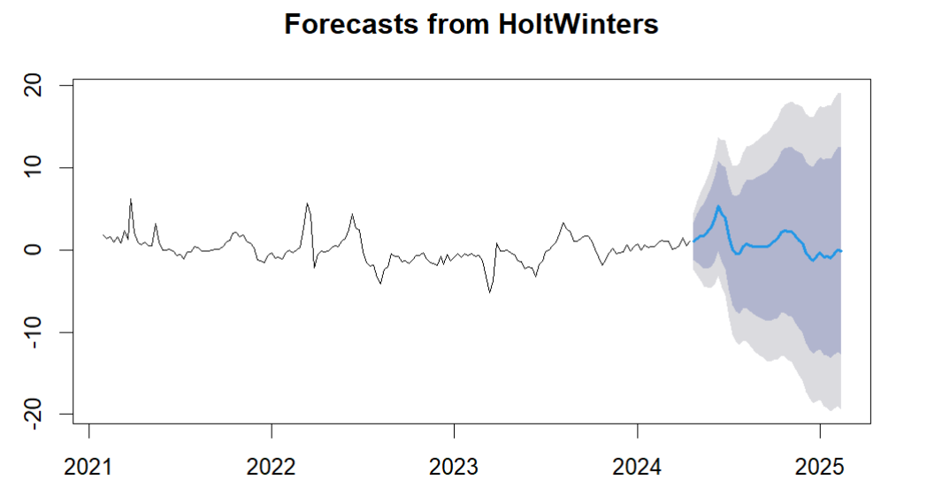
Figure 25. Holt - Winters forecast

4.2.3 STLF
STLF (Seasonal-Trend decomposition using Loess with Forecasting) method is used to model and forecast time series data. The stlf function is applied to the training dataset, which automatically decomposes the series into seasonal, trend, and residual components using LOESS (Locally Estimated Scatterplot Smoothing). The method is particularly suited to time series with pronounced seasonality and we align the forecast with the length of the test set like previous model to enable direct performance evaluation.
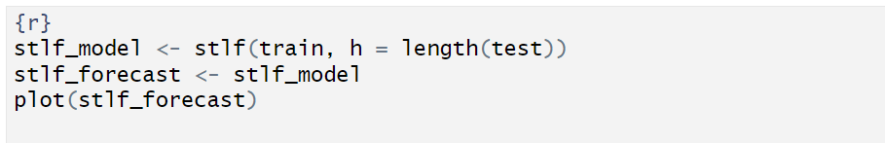
Figure 26. Fitting STLF
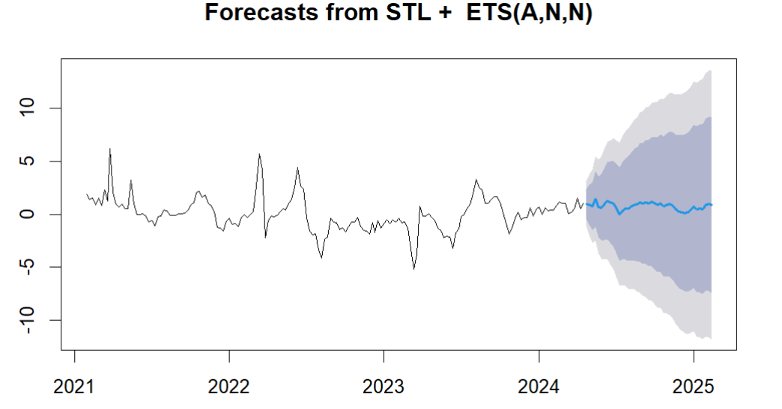
Figure 27. STLF plot

4.3 Multivariate Time Series Analysis
To address the influence of external factors on UK fuel prices and enhance forecasting accuracy, multivariate time series models were employed, incorporating Brent crude oil prices as an exogenous variable, the exogenous variable was cleaned, imputing missing values via linear interpolation to ensure a complete series. The data was merged with the fuel dataset by week ending dates using left join to ensure consistency.
4.3.1 SARIMAX
This code implements a SARIMAX (Seasonal AutoRegressive Integrated Moving Average with eXogenous regressors) model to forecast average fuel prices. The auto.arima() function automatically identifies optimal model parameters (p, d, q for non-seasonal components, and P, D, Q for seasonal components). The model uses oil prices as an exogenous variable through the xreg argument, allowing it to account for external market influences on fuel prices.
Forecasts are generated using the forecast() function, which leverages the trained SARIMAX model and future oil price values from the test dataset. The SARIMAX forecast output provides probability based predictions, including single value predictions (mean values) and confidence ranges. The code then extracts these mean values using the $mean property, which reflects the projected average fuel prices for the forecast period.

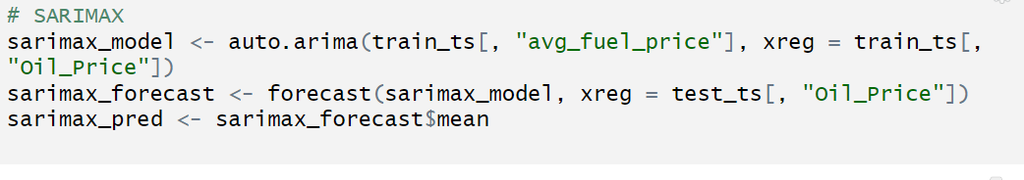
Figure 28 Fitting SARIMAX

4.3.2 Dynamic Linear Model (DLM)
In the DLM process, a function (build_dlm) defines how the model handles randomness in observations (dV) and system evolution (dW), The dlmMLE function finds the best-fitting parameters for the training data, starting with initial guesses (both set to 1) for these variance components.The optimised model generates predictions for the same number of periods as the test dataset. The final predictions are extracted as the model best estimate of future fuel prices from the forecast outputs.
This approach provides a flexible framework for modelling time series where the underlying trend might change gradually over time, while automatically determining the optimal balance between tracking recent changes and filtering out random noise.
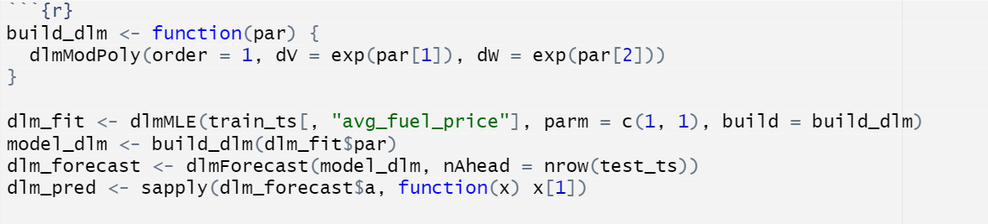
Figure 29 Fitting DLM

4.3.3 VAR
To implement a Vector Autoregression (VAR) model to forecast average fuel prices while accounting for relationships between multiple time series variables. First, the VARselect function identifies the optimal number of historical time laps (lags) to include in the model, evaluating up to 10 previous time periods and selecting the best configuration based on statistical criteria like the Akaike Information Criterion (AIC) which is identified as 3 as shown in figure 30. Forecasts are generated for the same number of periods as the test dataset. Finally, the code extracts the specific forecast values for average fuel prices from the results, focusing on the point estimates (fcst) to compare against actual test observations.
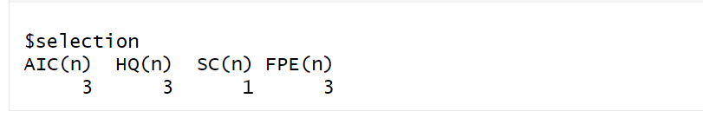
Figure 30 VARSelect result
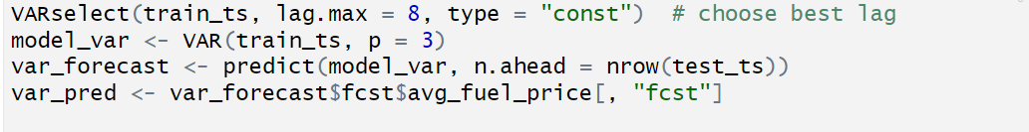
Figure 31 Fitting VAR
4.3.4 SVR
To prepare data for a Support Vector Regression (SVR) model, temporal dependencies from historical fuel prices and oil prices is incorporated. First, the differenced time series data is converted to a data frame to enable feature engineering. Three lagged variables are created:
- lag1: The average fuel price from the previous time period
- lag2: The average fuel price from two periods prior
- oil_lag1: The oil price from the previous period
The SVR model is trained on the lagged variables, this structure allows the model to learn how fuel prices evolve based on their own recent history and delayed oil price effects. Predictions are generated for the test period by feeding the lagged test data into the trained model. The approach combines time series dynamics with machine learning flexibility, enabling non-linear pattern recognition.
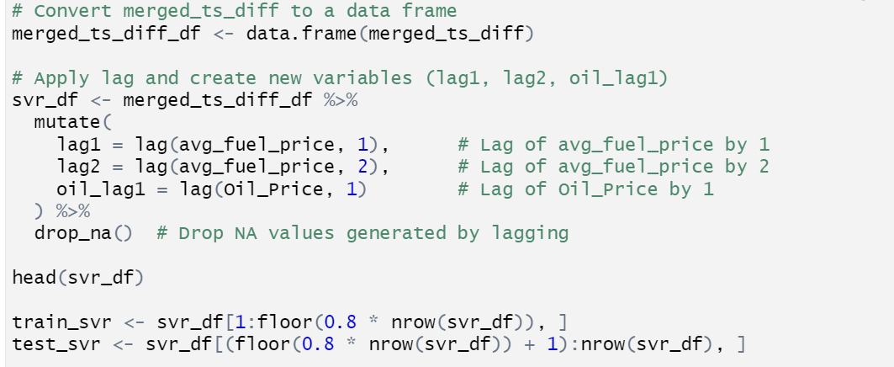
Figure 32. Formatting the data for SVR and RF
Figure 33. Fitting SVR
4.3.5 Random Forest
The code in figure 34 trains a Random Forest regression model to predict fuel prices using two lagged fuel price values and a lagged oil price as predictors. The method aggregates predictions from multiple decision trees trained on 80% of the data, generating test forecasts that balance non-linear pattern recognition with reduced overfitting risks.
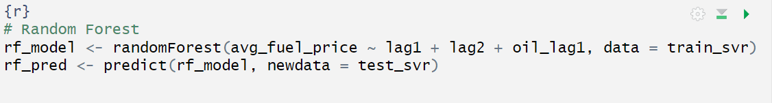
Figure 34 Fitting RF

4.4 Model Evaluation
To determine the most accurate forecasting approach for UK fuel prices, seven models were implemented and evaluated: SARIMA, STLF, Holt-Winters (traditional univariate approaches) and VAR, DLM, SARIMAX, SVR, and Random Forest (multivariate approaches incorporating exogenous variables). All models were trained using an 80/20 train and test split to ensure robust validation.
The performance of each model was assessed using error metrics Root Mean Square Error (RMSE) which measures the square root of the average squared differences between predicted and actual values and Mean Absolute Error (MAE) which represents the average absolute difference between predicted and actual values.
SVR performs the best with the lowest RMSE - 0.5089 and MAE - 0.4270, followed closely by Random Forest RMSE - 0.6172 and MAE - 0.5061, Holt-Winters performs the worst with RMSE - 2.1801 and MAE - 1.7899, possibly due to complex patterns, SARIMA and SARIMAX, while better than Holt-Winters, still lag behind machine learning models like SVR and Random Forest.
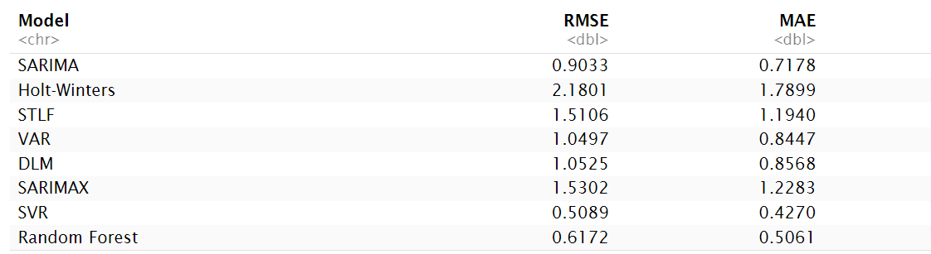
Figure 35 Model evaluation

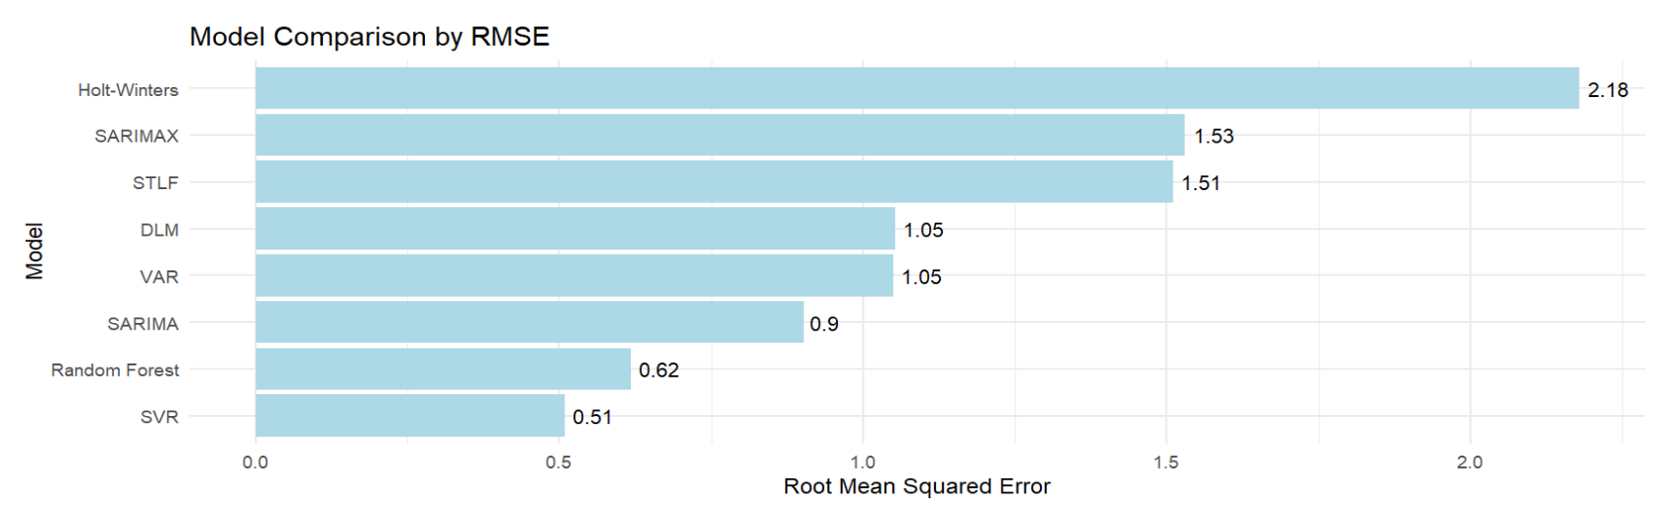
Figure 36 Model comparison bar plot
Plotting the best performing model predicted and actual values in the test set showed how closely SVR predicted values are to the actual value.
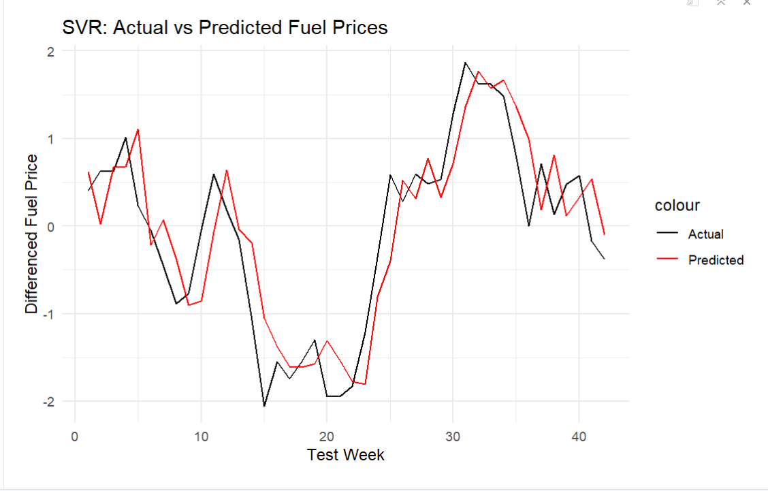
Figure 37 SVR: Actual vs Predicted

4.5 Forecast
The final 24-week forecast was generated using the SVR model as it is the best model in this analysis, recursive forecasting was performed using the last observed data point and predicted lags. Predictions are mapped to 24 future weekly timestamps with results structured in a data frame showing future date labels (Week_Ending) and predicted fuel prices (Forecasted_Fuel_Price) as shown in figure 38 below.
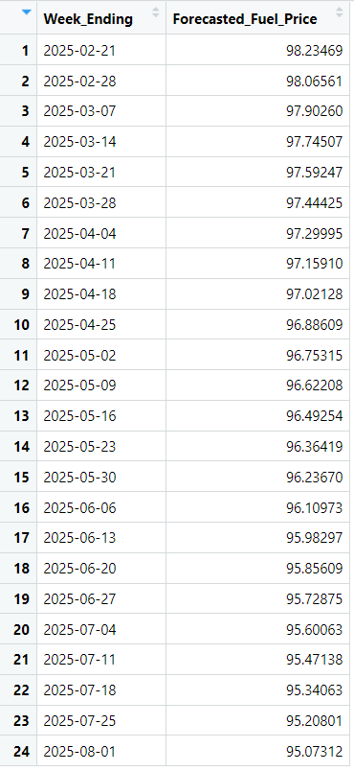
Figure 38. Forecasted SVR values

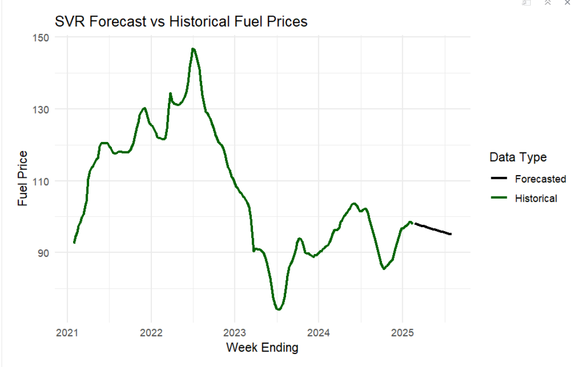
Figure 39. SVR historical and forecasted plot

4.6 Summarisation of Business Question I
Are there trends and seasonal patterns in UK average fuel prices?
The STL decomposition decomposes the time series into trend, seasonal and residual components. The decomposition reveals a clear seasonal pattern repeating every 52 weeks, with no significant trend. These patterns justify the use of seasonal models like SARIMA and STLF for forecasting.
To investigate the trends and seasonality in fuel prices, STL decomposition was applied to the fuel price time series using stl() in R (Figure 15).

4.7 Summarisation of Business Question II
Do crude oil prices influence average fuel prices in the UK?
Granger causality tests and correlation analysis were applied to assess the influence of Brent crude oil.
The Granger Causality Test revealed that lagged crude oil prices significantly improve fuel price predictions (F-statistic = 3.6856, p = 0.02677), Since the p value is less than 0.05, we reject the null hypothesis and conclude that lagged crude oil prices have a statistically significant effect on fuel prices. This indicates crude oil prices Granger-cause fuel prices, confirming their predictive utility and validating their use as an exogenous variable.

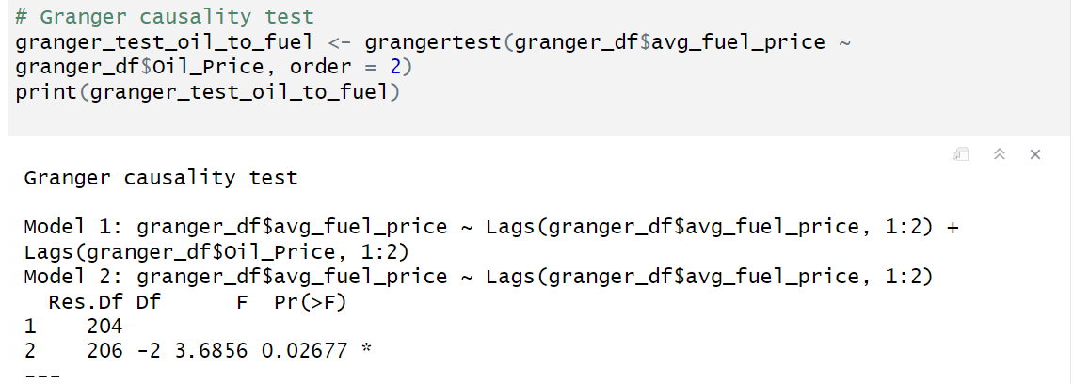
Figure 40 Granger causality

4.8 Summarisation of Business Question III
Does average road fuel sales volume influence the accuracy of multivariate time-series forecasts?
SARIMAX models were fitted with and without road fuel sales to evaluate the impact of the variable. Including road fuel sales significantly improved the model forecasting accuracy, reducing RMSE from 1.53 to 1.07. Road fuel sales improve multivariate model performance by capturing demand dynamics not explained by crude oil prices alone.
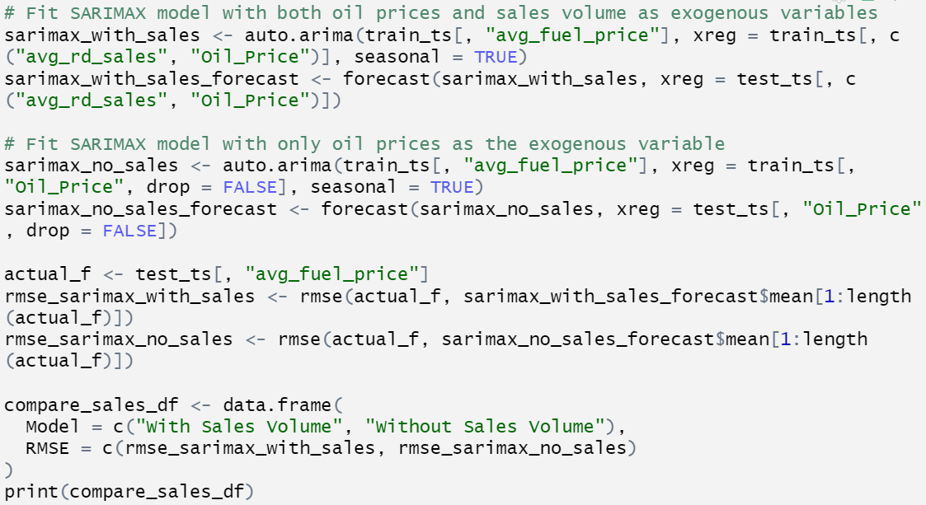
Figure 41 Road sales influence

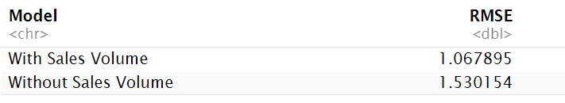
Figure 42Road sales influence result

4.9 Business Question IV
Which forecasting model provides the best accuracy for UK fuel prices?
The SVR model achieved the lowest RMSE and MAE, followed closely by the Random Forest model. Both models outperformed traditional statistical approaches. Models compared include SARIMA, STLF, Holt-Winters, VAR, SARIMAX, SVR, and Random Forest (Figure 35).

4.10 Business Question V
What are the forecasted average fuel prices for 24 weeks into the future using historical patterns?
The best model (SVR) was refit on the full dataset and used for a 24 - week recursive forecast .The SVR model forecasts a moderate fall in fuel prices over the next 24 weeks as shown in Figure 38 above, providing actionable insights for pricing, logistics and budgeting.

5. Conclusion and Recommendations

5.1 Conclusion
This report successfully addressed the challenge of forecasting UK average fuel prices by applying different time-series models, ranging from traditional statistical methods (SARIMA, Holt-Winters, STLF) to multivariate and machine learning approaches (VAR, DLM, SARIMAX, SVR, Random Forest). Through STL decomposition, a 52-week seasonal pattern was identified in UK fuel prices, with no significant long-term trend, justifying the use of seasonal models. Granger causality tests confirmed that Brent crude oil prices significantly influence UK fuel prices (F-statistic = 3.6856, p = 0.02677) as shown in Figure 40, validating their inclusion as an exogenous variable in multivariate models. Furthermore, incorporating average road fuel sales as an exogenous variable improved forecasting accuracy, reducing SARIMAX’s RMSE from 1.53 to 1.07 Figure 42.
Model evaluations revealed that SVR achieved the highest forecasting accuracy with an RMSE of 0.5089 and MAE of 0.4270, outperforming Random Forest (RMSE: 0.6172, MAE: 0.5061) and traditional models like Holt-Winters (RMSE: 2.1801, MAE: 1.7899), as shown in Figure 35 and Figure 36. This superiority is attributed to SVR ability to model non-linear relationships and handle exogenous variables effectively. Using SVR, a 24-week forecast predicted a moderate decline in fuel prices, as visualised in Figure 39, offering stakeholders valuable insights for planning. These results enable fuel retailers, logistics providers, policymakers and consumers to mitigate the risks of price volatility, optimise operational strategies and enhance economic resilience in the UK fuel market.

5.2 Recommendation
For future research on SVR attention should be focused on model optimisation. While machine learning models (SVR and Random Forest) outperformed traditional statistical approaches in this analysis, their full potential may lie in combining strengths with established time-series methods. We recommend piloting hybrid models such as a SARIMAX/SVR that merge the interpretability of statistical models with machine learning adaptability to non-linear patterns. SARIMAX reliably captures linear trends and oil price linkages, while SVR handles complex volatility, Hybrid models reduce overreliance on any single method, critical in markets prone to geopolitical or economic shocks. Academic studies show hybrid forecasts can improve accuracy compared to individual models (Alharbi and Csala, 2022).
Brent crude oil prices was the primary external variables used in this analysis, future models could incorporate additional factors such as exchange rates, economic indicators, specific tax changes like fuel duty or consumer sentiment to further enhance forecast accuracy, especially in the face of global market changes (Baumeister and Kilian, 2016; Hang and Tu, 2007).
Fuel Retailers can adopt SVR-based forecasting models to optimise pricing and procurement strategies, using forecasts to adjust pricing strategies to remain competitive while maintaining profitability as improved accuracy minimizes financial losses from sudden price drops. Logistics Providers can leverage the 24-week forecast to align transport schedules with anticipated fuel costs. The inclusion of road fuel sales data, which improved SARIMAX accuracy highlights the importance of demand dynamics. Logistics firms should integrate demand data into forecasting systems to enhance inventory planning, potentially achieving cost savings by avoiding overstocking or stockouts. Policymakers should incorporate the causal relationship between Brent crude oil prices and UK fuel prices into policy interventions. With crude oil prices Granger-causing fuel price movements, policymakers can develop proactive measures, such as price stabilisation schemes, to mitigate inflation risks driven by fuel price volatility. Regular monitoring of global oil market trends is recommended to anticipate price shocks.

